Mystery Sounds
This package contains spectrograms of seven ocean sounds. Your job is to match the spectrogram with the noises listed below.

Ocean Sounds | Spectrogram #
a small boat

an unknown mammal, likely a piniped (seal)

Biggs killer whale

blue whale

grey whale

humpback whales

sperm whale

If you need help, here are some clues.
- In general, look at the pattern, intensity, and place in the spectrogram, plus any harmonies that are visible.
- Boats create a lot of noise over long periods of time building in noise level and intensity as they get closer to the location of the hydrophone.
- Marine mammals, such as pinnipeds, have low, random calls that vary in length. Further, this recording includes the initial sound and a very distinctive harmony.
- Biggs killer whales have relatively short calls that vary greatly in frequency within the single call. Also, the harmonies from these particular clips are concentrated together.
- Blue whale calls are extremely low frequency, but have very high intensity. In the clip, they may be difficult to distinguish from background noise though they have much higher intensity than the background noise.
- The grey whale has very low frequency calls, though they are not as intense as the blue whales call. The grey whale calls are also repetitive, starting low and building slightly before finishing.
- The clip of the humpback includes low frequency, repetitive sounds. The calls have very small changes in frequency overall, appearing as long thin, repeating line.
- The sperm whale clip includes high frequency clicks. These clips are extremely short and repetitive, appearing either grouped together or at evenly spaced intervals.

Spectrogram 1
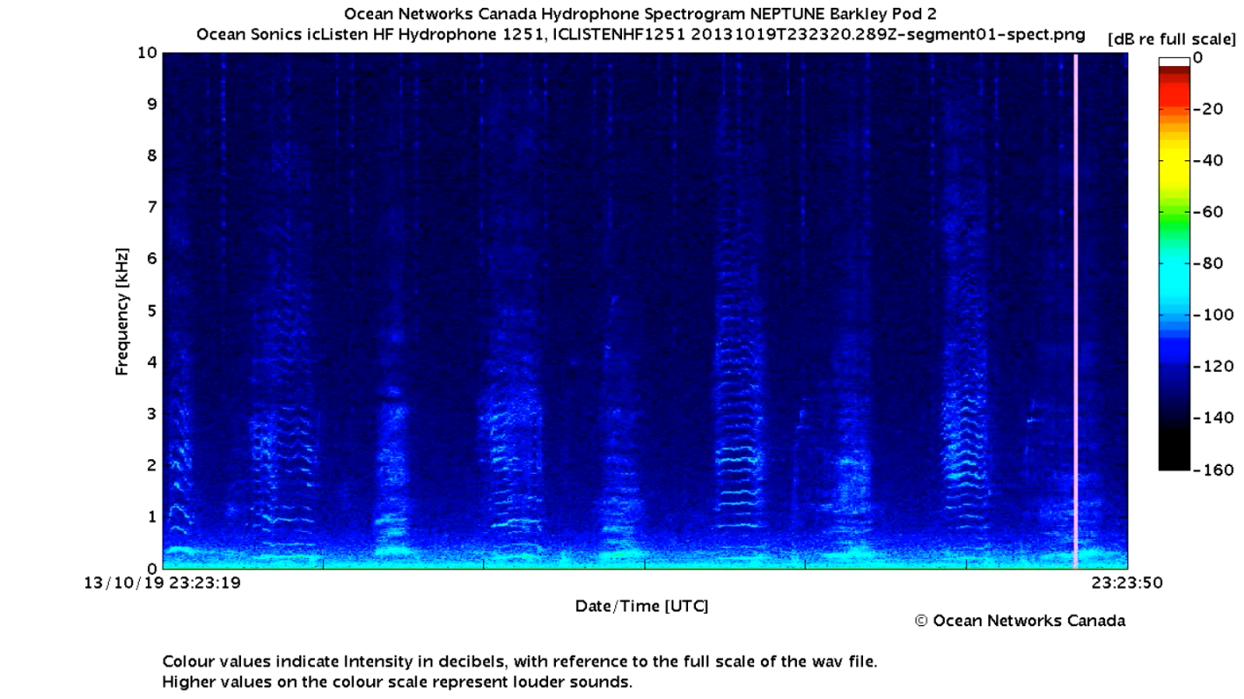

Spectrogram 2

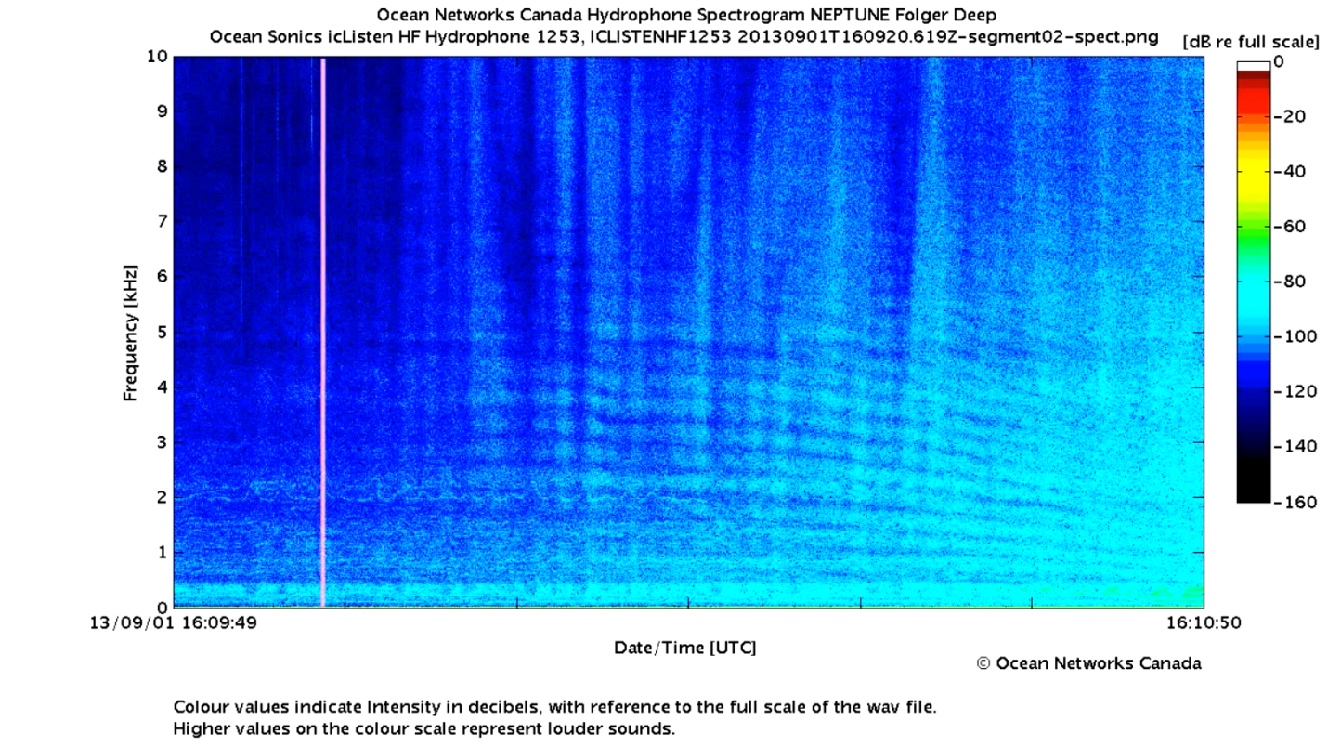
Spectrogram 3
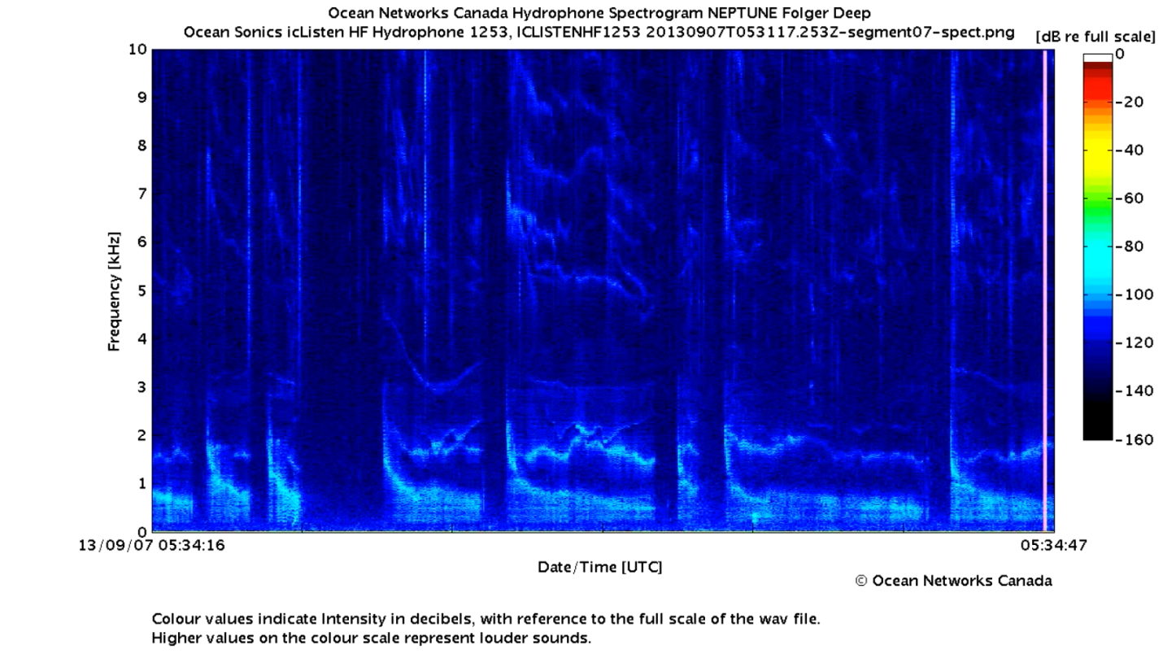

Spectrogram 4
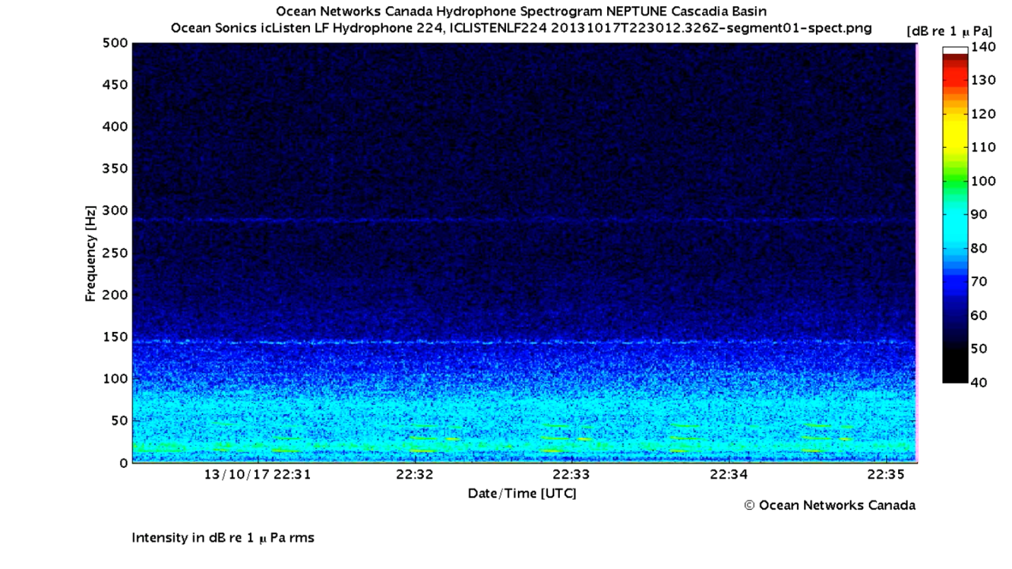

Spectrogram 5
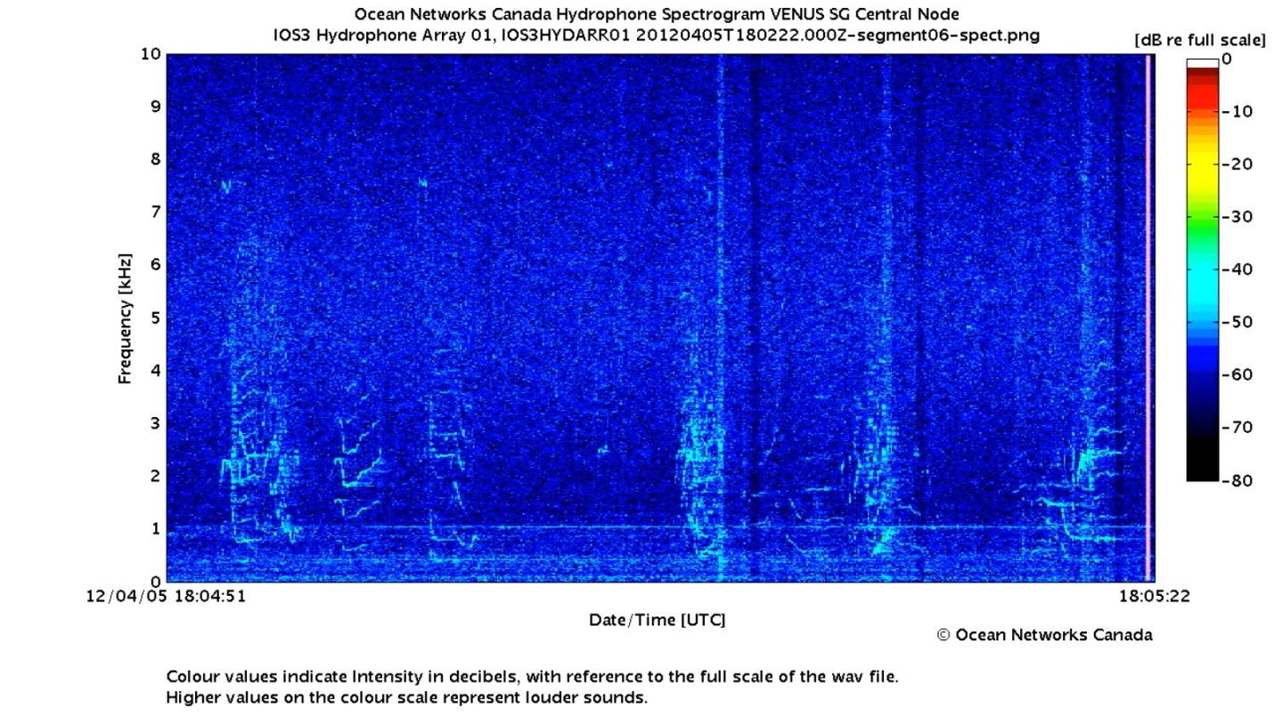

Spectrogram 6
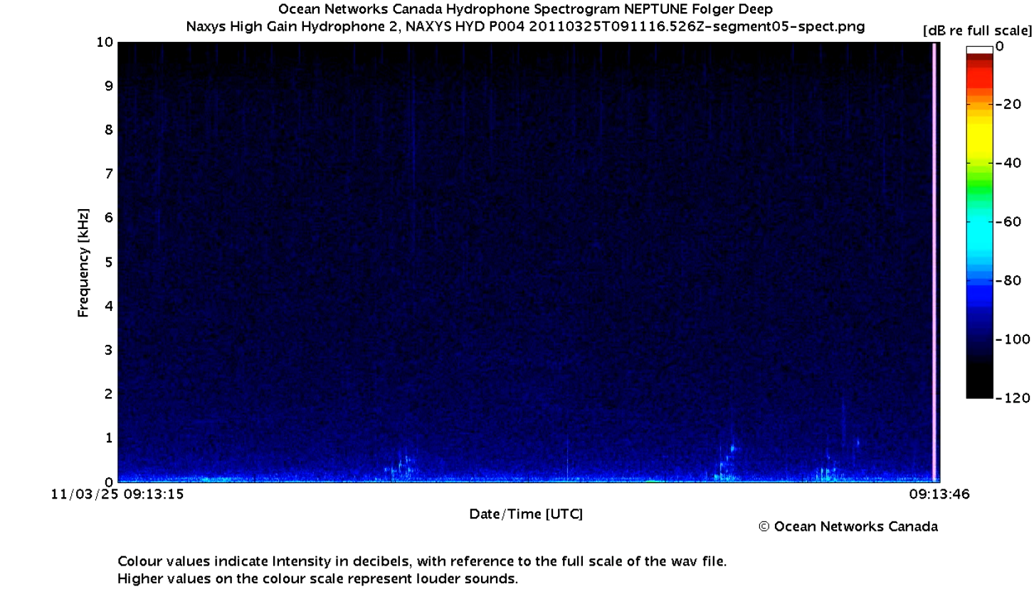

Spectrogram 7
